

**UNIVERSITY INSTITUTE OF ENGINEERING**

**Department of Computer Science & Engineering**

# Subject Name: MOBILE APPLICATION DEVELOPMENT LAB

**Subject Code:** 20CSP-356

**Submitted to: Submitted by:**

Faculty name: Mr. Hemant Kumar Name: Sahil Kaundal

UID: 21BCS8197

Section: 616

Group: A

**INDEX**

|  |  |  |  |  |  |  |
| --- | --- | --- | --- | --- | --- | --- |
| **Ex. No** | **List of Experiments** | **Conduct (MM: 12)** | **Viva**  **(MM: 10)** | **Record (MM: 8)** | **Total**  **(MM: 30)** | **Remarks/Signature** |
| 1.1 | Installing and running applications on android studio |  |  |  |  |  |
| 1.2 | To design an android application to display Hello World |  |  |  |  |  |
| 1.3 | **Create Application by Using Widgets** |  |  |  |  |  |
| 2.1 |  |  |  |  |  |  |
| 2.2 |  |  |  |  |  |  |
| 2.3 |  |  |  |  |  |  |
| 2.4 |  |  |  |  |  |  |
| 3.1 |  |  |  |  |  |  |
| 3.2 |  |  |  |  |  |  |
| 3.3 |  |  |  |  |  |  |

**Experiment 1.1**

**Student Name:** Sahil Kaundal **UID:** 21BCS8197

**Branch:** CSE (Lateral Entry)  **Section/Group:** 616/A

**Semester:** 6th **Date of Performance:** 16/02/2023

**Subject Name:** Mobile Application Development Lab **Subject Code:** 20CSP-356

1. **Aim:** Installing and running applications on android studio.
2. **Objective:** Installing and running applications on android studio.

Android Studio is the official IDE (Integrated Development Environment) for Android app development and it is based on JetBrains’ IntelliJ IDEA software. Android Studio provides many excellent features that enhance productivity when building Android apps, such as:

* A blended environment where one can develop for all Android devices
* Apply Changes to push code and resource changes to the running app without restarting the app
* A flexible Gradle-based build system
* A fast and feature-rich emulator
* GitHub and Code template integration to assist you to develop common app features and import sample code
* Extensive testing tools and frameworks
* C++ and NDK support
* Built-in support for Google Cloud Platform, making it easy to integrate Google Cloud Messaging and App Engine, and many more.
* Provides GUI tools that simplify the less interesting parts of app development.
* Easy integration with real time database ‘firebase’.

1. **System Requirements:**

* Microsoft Windows 7/8/10 (32-bit or 64-bit)
* 4 GB RAM minimum, 8 GB RAM recommended (plus 1 GB for the Android Emulator)
* 2 GB of available disk space minimum, 4 GB recommended (500 MB for IDE plus 1.5 GB for Android SDK and emulator system image)
* 1280 x 800 minimum screen resolution
* Java JDK5 or later version
* Java Runtime Environment (JRE) 6 Android Studio

1. **Steps/Program:**

**Installation Guide:**

**Step 1:**Head over to this link https://developer.android.com/studio/#downloads to get the Android Studio executable or zip file.

**Step 2:**Click on the **Download Android Studio** Button.

Click on the “I have read and agree with the above terms and conditions” checkbox followed by the download button.

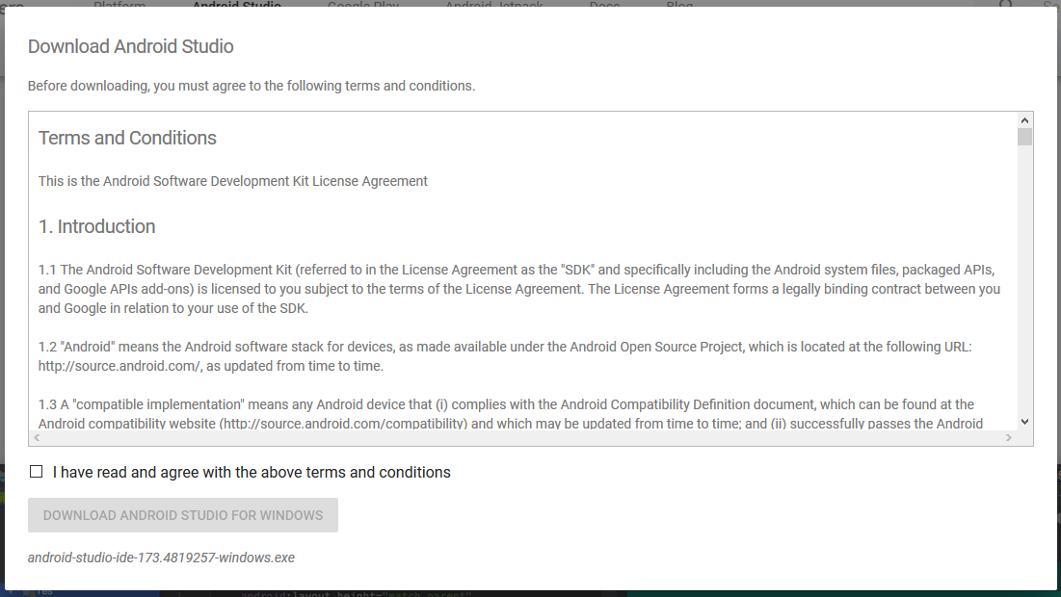

Click on the Save file button in the appeared prompt box and the file will start downloading.

**Step 3:**After the downloading has finished, open the file from downloads and run it. It will prompt the following dialog box.

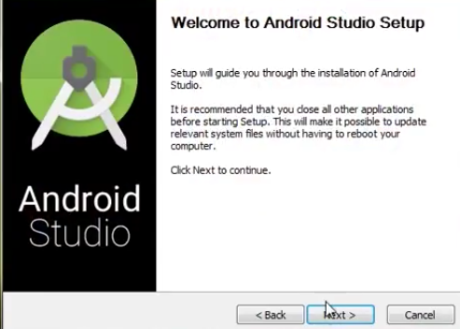

Click on next. In the next prompt, it’ll ask for a path for installation. Choose a path and hit next.

**Step 4:**It will start the installation, and once it is completed, it will be like the image shown below.

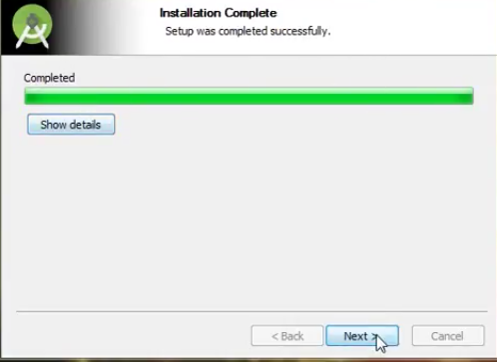

Click on next.

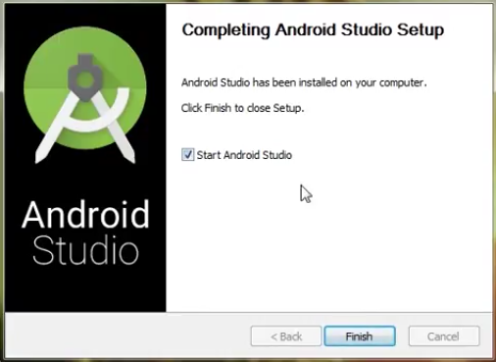

**Step 5:**Once “**Finish**” is clicked, it will ask whether the previous settings need to be imported [if the android studio had been installed earlier], or not. It is better to choose the ‘Don’t import Settings option’.

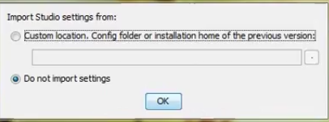

Click the **OK**button.

**Step 6:**This will start the Android Studio.

Meanwhile, it will be finding the available SDK components.

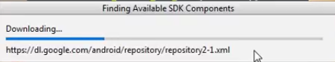

**Step 7:**After it has found the SDK components, it will redirect to the Welcome dialog box.

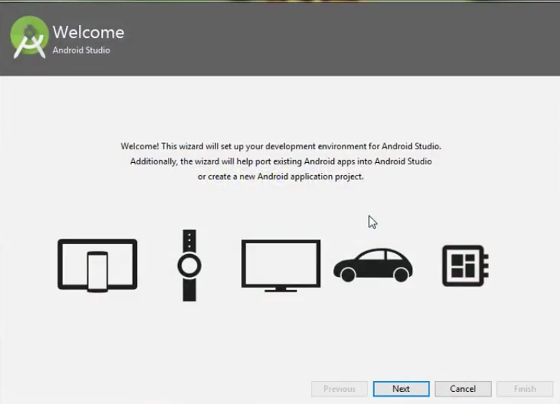

Click on **Next**.

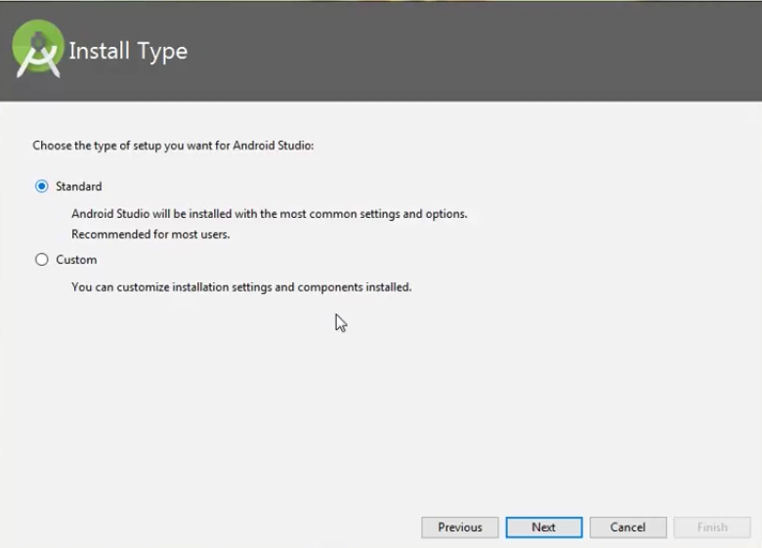

Choose Standard and click on Next. Now choose the theme, whether the Light theme or the Dark one. The light one is called the IntelliJ theme whereas the dark theme is called Dracula. Choose as required.

Click on the Next button.

**Step 8:**Now it is time to download the SDK components.

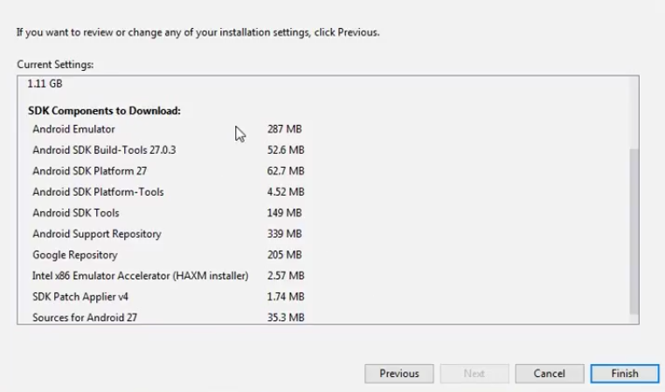

Click on Finish. Components begin to download let it complete.

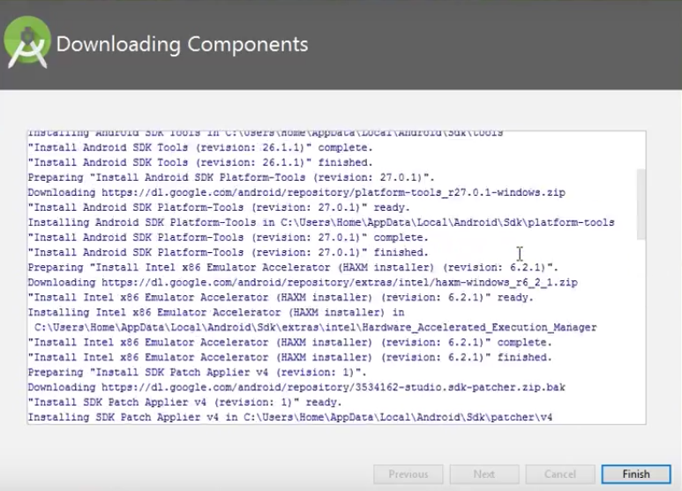

The Android Studio has been successfully configured. Now it’s time to launch and build apps. Click on the Finish button to launch it.

**Step 9:**Click on **Start a new Android Studio project** to build a new app.

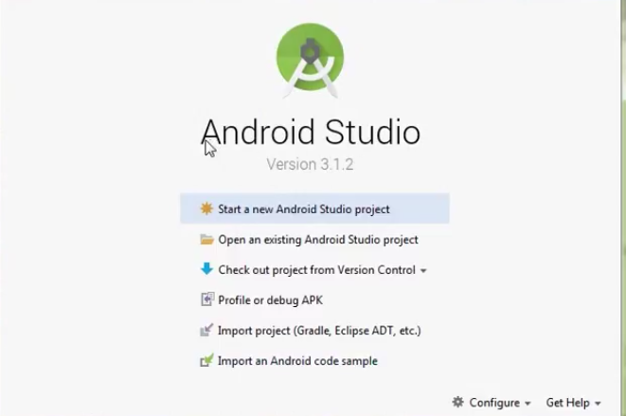

**Running Applications on Android Studio:**

The panel on the left side of the android studio window has all the files that the app includes. Under the java folder, observe the first folder containing the java file of your project.

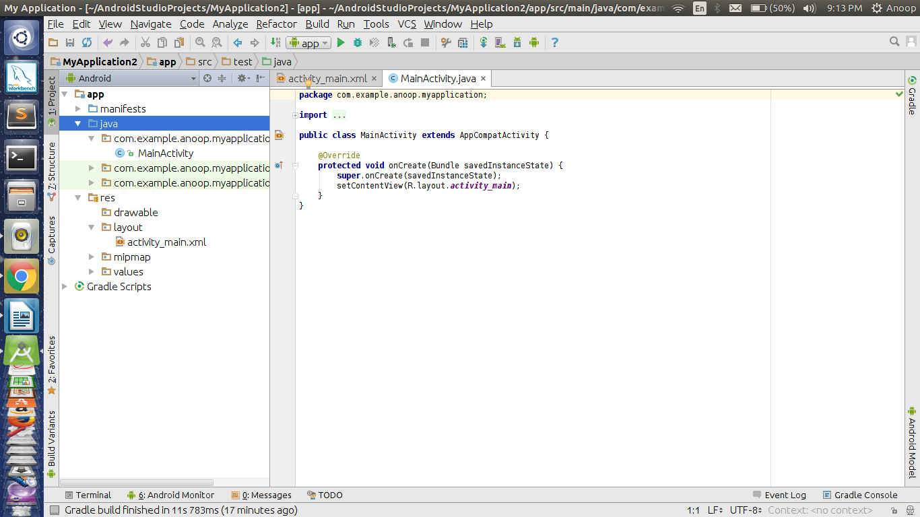

For every activity, a “.java” file and a “.xml” file is created. In this case for MainActivity, “MainActivity.java” and “activity_main.xml” are created.

The above java file shows us the default code that is present when an app is created. An activity is created that extends AppCompactActivity class.

The “res” folder contains “layout” subfolder, which includes the xml files of the projects.

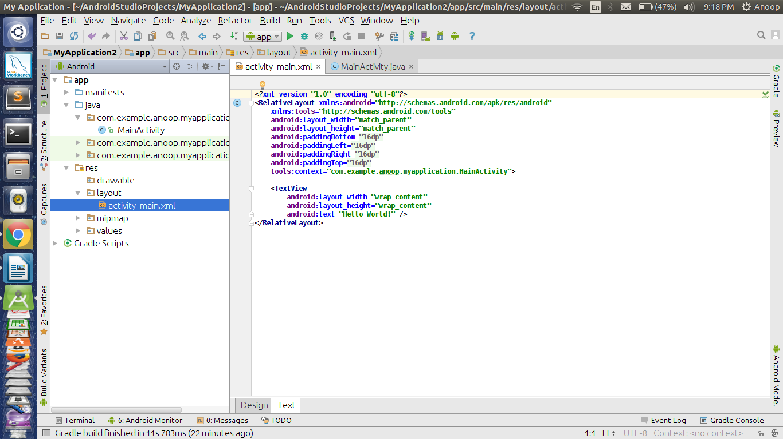

You can find the activity_main.xml file under the layout folder. This the XML file corresponding to the MainActivity. There is an onCreate function that overrides a function of AppCompactActivity class. onCreate(Bundle) is where you initialize your activity. When the activity is first started, then both onCreate() methods are called. But after the first start of Activity, the onCreate() of application will not be called for subsequent runs.

* Now, consider the activity_main.xml file, it contains various tags similar to HTML. The first tag ensures the version. The second tag is usually the Layout tag. There are various types of Layouts but for now, let us go with the default RelativeLayout. This is a layout that places the widgets relative to screen size.

There is a TextView widget by default. This “TextView” is basically the Text field that displays the text specified. It has various attributes. For now, consider the default attributes present. The layout_width and layout_height are the width and height of the widget occupied in the screen. The attribute “wrap_content” refers to width or height being restricted to the content of the text.

The text attribute takes a string in quotations ( i.e., “ ” ). The content within this is displayed on the screen.

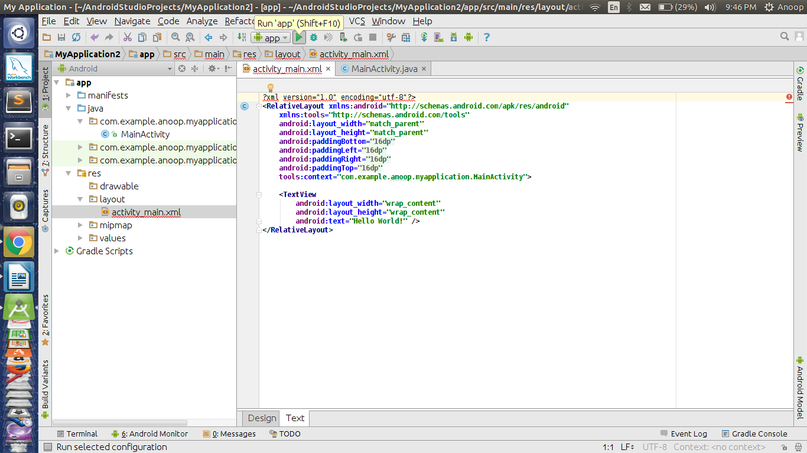

Now, click the “Run” option at the Toolbar at the top. You can observe the option being highlighted in the image below.

You would get a pop-up as in the image below.

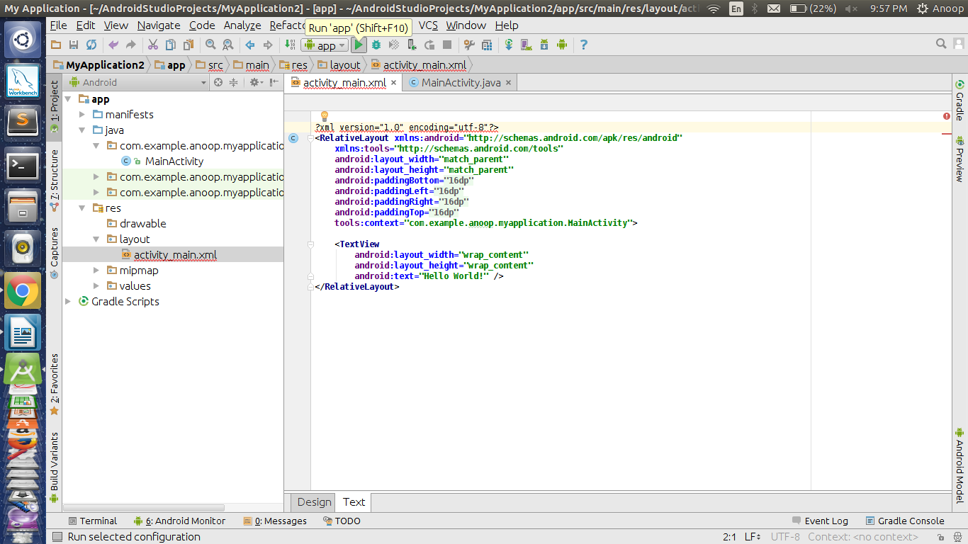

You can either choose the emulator or you can connect your phone and find them listed under Connected Devices but for this you must enable the developer options in your phone and set the USB debugging mode on.

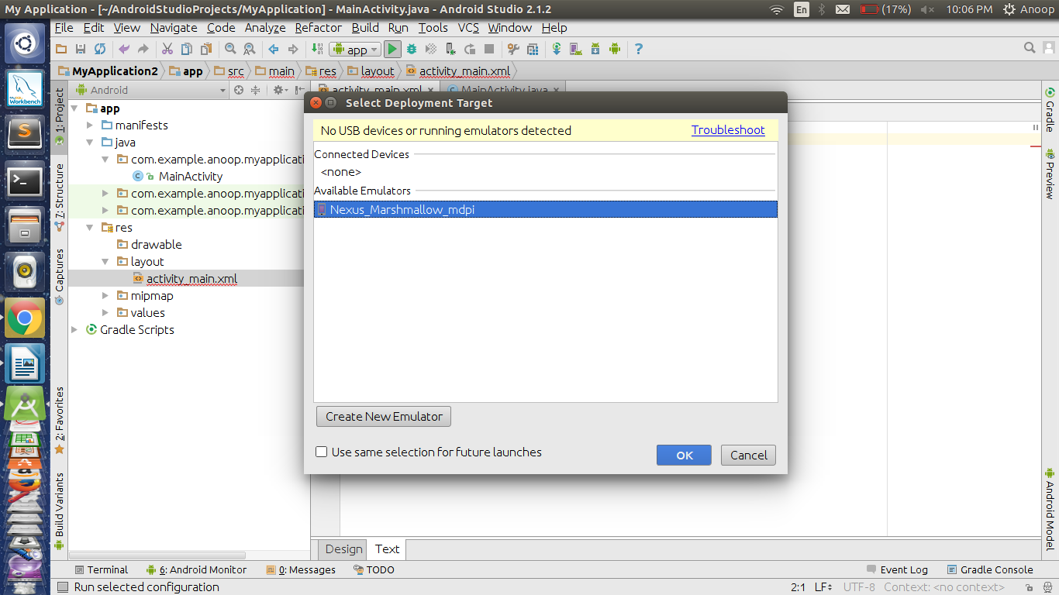

Once done, click on OK.

Usually, the emulator consumes a lot of RAM. The more RAM size you have, the faster your emulator will work. Generally, 4GB is the descent RAM size. Size more than that would increase the performance of your emulator.

The image below shows the working of the first app, My Application. You can find all the basic functionalities that your phone has, on the emulator, like Home button, back button, power, etc.

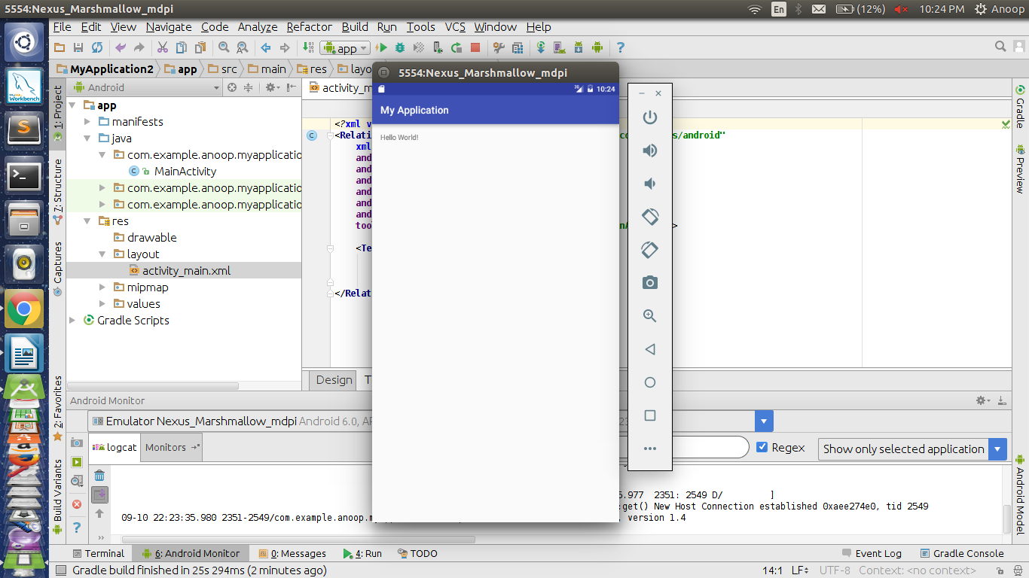

**Learning outcomes (What I have learnt):**

* Learnt about installation of android studio.
* Learnt about running application on android studio.

**Evaluation Grid (To be created as per the SOP and Assessment guidelines by the faculty):**

|  |  |  |  |
| --- | --- | --- | --- |
| Sr. No. | Parameters | Marks Obtained | Maximum Marks |
| 1. |  |  |  |
| 2. |  |  |  |
| 3. |  |  |  |
|  |  |  |  |